2. Rotation of Orientation Data around an Optional Axis
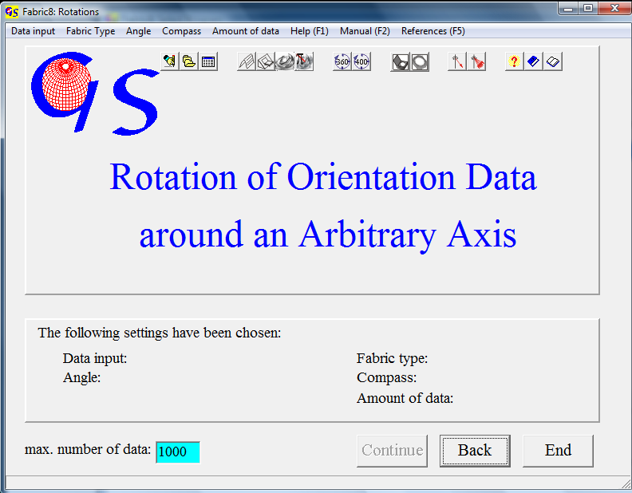 Fig.1

This program (Fig.1) allows rotations of three-dimensionally distributed orientation data (azimuth of dip / angle of dip or strike/ dip angle/ dip direction) around rotation axes of any orientation. The calculation is carried out by use of a rotation-tensor (WALLBRECHER, 1986:24ff).
Data input can be manually, from a data file, or from an Excel worksheet (Fig.2)
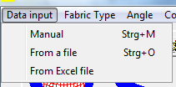
Fig. 2

Manual input also includes direct input of azimuth and tilt angle from a universal stage. These data can be axes (i. e. quartz<c>axes) or normals to planes (i.e. normals to mica-planes). The program changes this type of data to azimuth and angle of dip. Output is in this format. The data type must be clicked in the menu "Fabric Type" (Fig. 3). Manual input can be either in the 0-360° or in the 0-400°-scale.

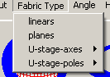  Fig 3

Manual input can consist of data, taken with a Clar compass (azimuth of dip and angle of dip) or of data taken with a Brunton compass (strike, dip angle, dip direction north or south).
For manual input you can choose between input of single data or input of a set of data (Fig. 4).

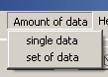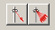
Fig. 4

In non-manual input the options “U-stage axes” and "U-stage poles" are inactive, because already saved data always have the format ‘azimuth/angle of dip’.
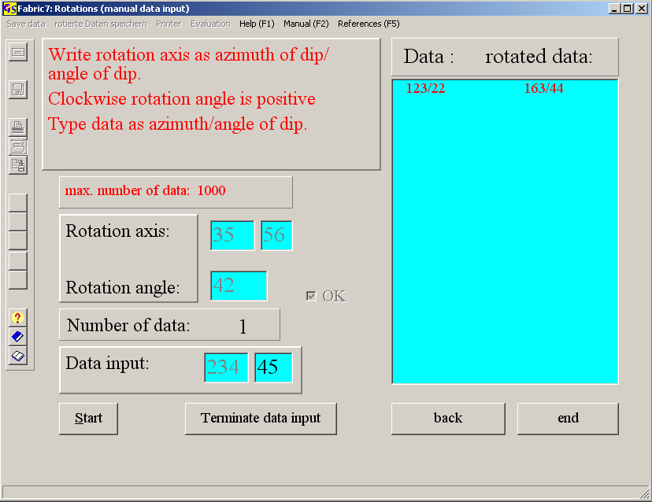
Fig. 5

Fig. 5 shows the form for manual input of data measured with the Clar-Compass after clicking on start and input of the rotation axes (azimuth and angle of dip) and rotation angle in clockwise direction. The data input and the rotated direction appear in the list-field.
Fig. 6 shows the form for input of data measured with the Brunton-Compass. Data are typed as strike angle, angle of dip, and direction of dip (‘n’ for North or ‘s’ for South).
When input data are U-stage measures, you have to choose either “Leitz” or “Zeiss” on the panel “U-stage” after input of the rotation axis and rotation angle (Fig. 7).

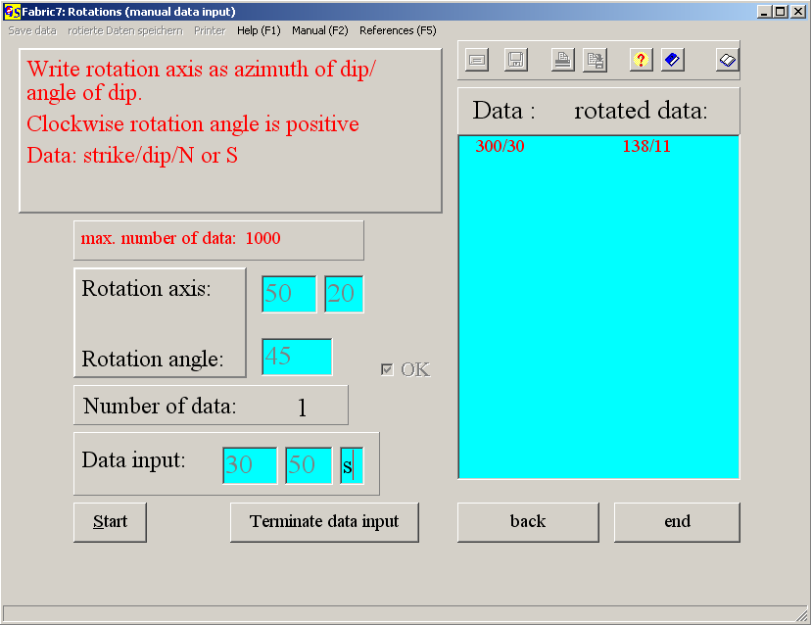
Fig. 6

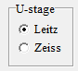 Fig. 7

With the choice of the option "Single data" in menu "Amount of data" you can rotate single data around their individual rotation axis. With the option "Set of data" you apply the same rotation axes to a set of data. Data input is terminated by pressing the button “Terminate data input”. The menus "Save data“, "Save rotated data“, "Printer“, and "Evaluation" are then active.

Input from a file:
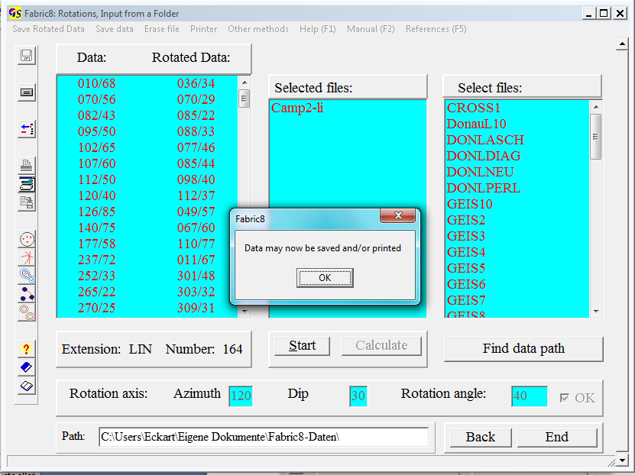Fig. 8

Fig. 8 shows the form for data input from a file. The following steps were carried out:
- Clicking on “Start”
- Clicking on the file(s) you want to work with (Camp2-Li)
- Input of rotation axis (azimuth, 'Enter', angle of dip 'Enter')
- Input of the rotation angle (angle, 'Enter' and clicking in the 'OK'-field).

Saving and printing of rotated data and evaluation is the same as in program 1 .
Fig. 9 shows the beginning of an *.rtf-File of the data and results in Fig. 8.

Rotation of Orientation Data
Day of calculation: Sunday, 11. Feb. 2007 12.20 h
File :Camp2-li.LIN
Data are Linears
Rotation axis = 35/40
Rotation angle = 50°
Anzahl = 164
Data : Rot.: Data : Rot.: Data : Rot.: Data : Rot.:
010/68 353/44 070/56 027/68 082/43 069/70 095/50 061/81
102/65 333/77 107/60 327/82 112/50 189/87 120/40 180/75
126/85 319/57 140/75 304/64 177/58 268/52 237/72 304/39
Fig.9

Data input from an Excel sheet
This option only runs without errors when “Excel.exe“ is not in the task manager. Click „Ctrl-Alt-Del“ to open the task manager and delete Excel when it shows up (Fig. 10).

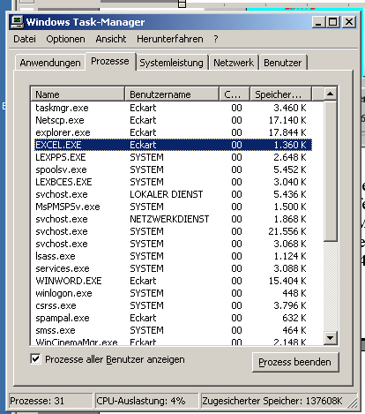 Fig. 10
Fig. 11 shows the form for data input with Excel.
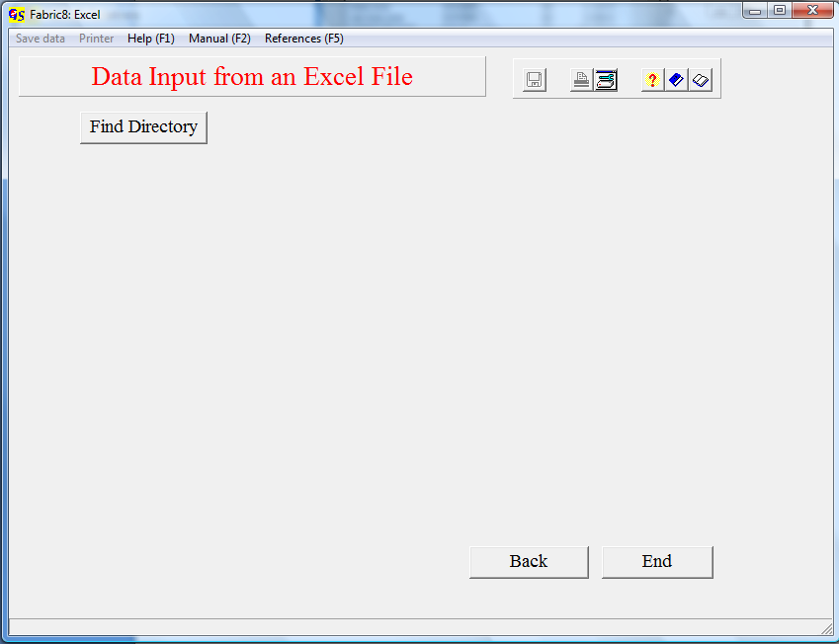Fig. 11
Clicking “Find Directory” opens a window to find the path to the Excel sheet (Fig. 12). Double click the folder which contains the Excel file, then press “OK”.
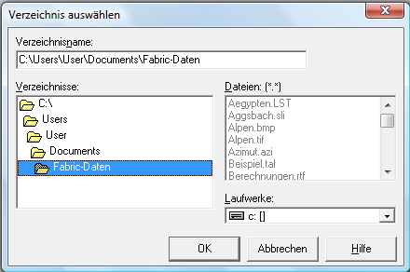
Fig. 12
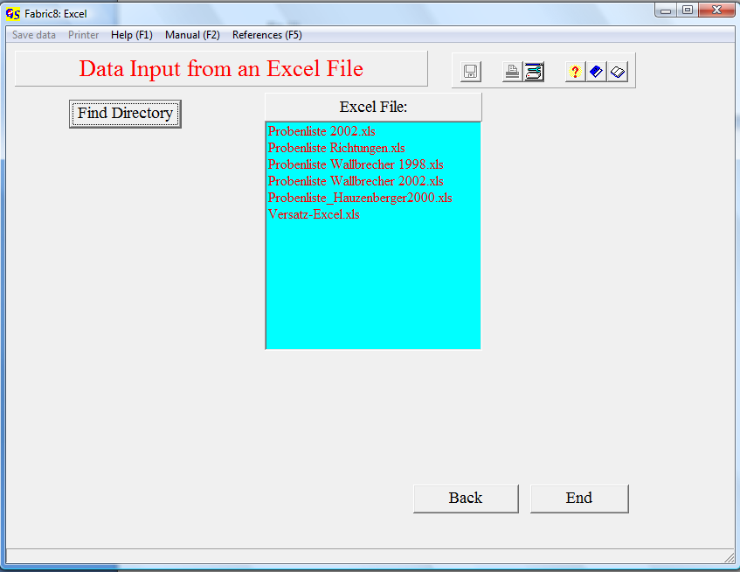
Fig. 13
All Excel files of the selected folder appear in the list field ‘Excel File’ (Fig. 13). Click the file you want to work with, and choose the worksheet that contains the data. Now the message that the Excel file will be opened appears (Fig. 14).
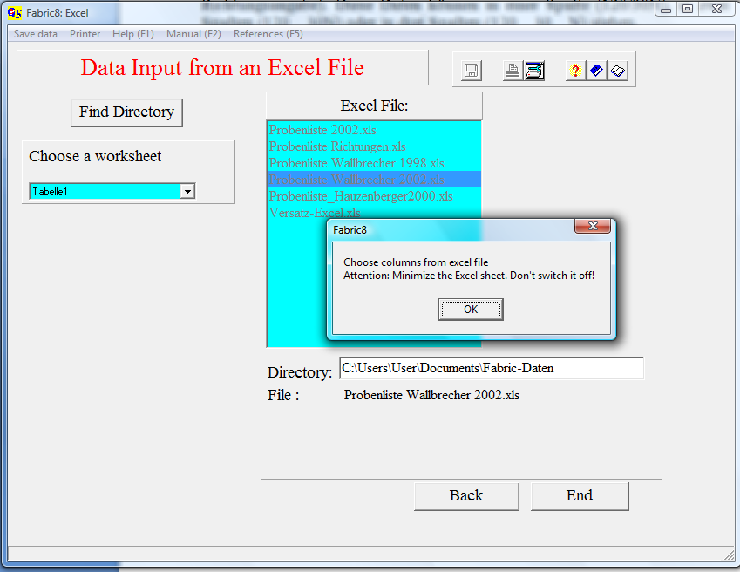
Fig. 14

Clicking ‘Ok’ shows the Excel file (Fig. 15).

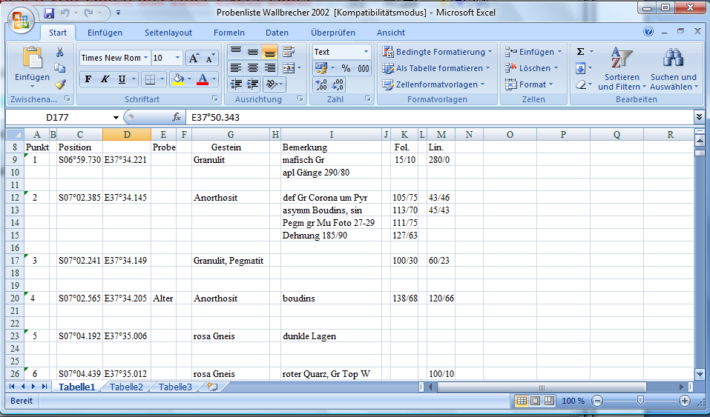
Fig. 15

The data list can have several formats:
Azimuth of dip and angle of dip can be in the same row or in separate rows.
If they are in the same row you have mark the separator.
The Excel sheet may also contain data, measured with a Brunton compass (strike, dip, direction of dip). these dat can be in one row (120/30N), in two rows (120 30N) or in three rows (120 30 N).
Minimize the Excel sheet. Do not switch it off!
Now the input fields for the first and last line of the data block, you want to work with, appear. If data are in on e row, put the separating sign in the field ‘Separator’. Clicking “‘OK” brings the data in the list field on the right side (Fig.16).
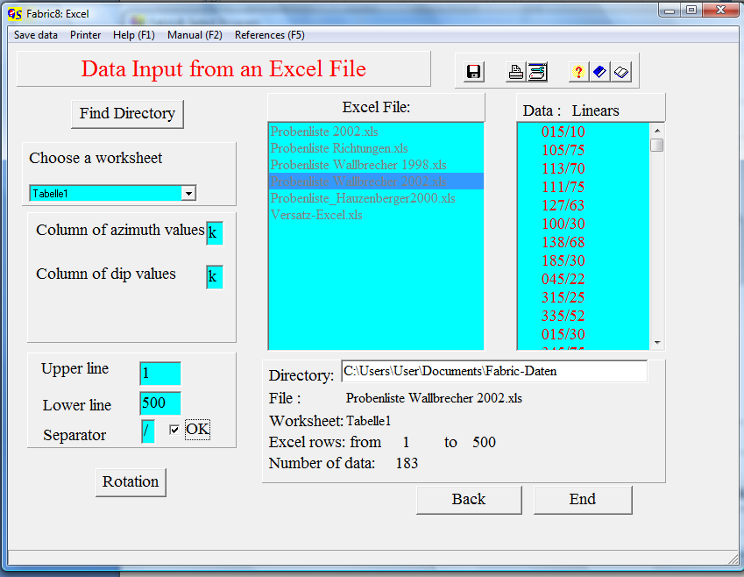
Fig. 16
Clicking ‘Rotation’ opens the form for the rotation (Fig. 17).

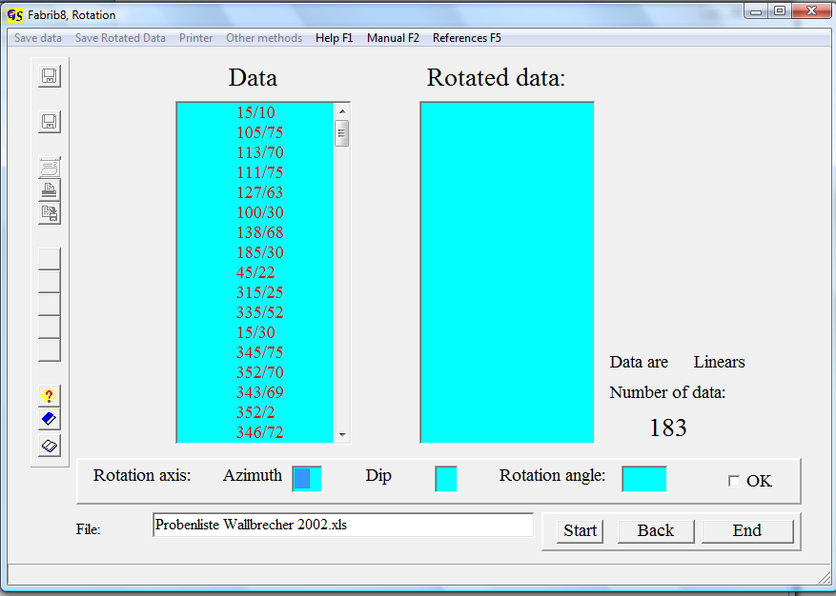
Fig. 17
After input of azimuth and dip of the rotation axis and the rotation angle (clockwise), the rotated data appear in the list field ‘Rotated Data’ (Fig. 18). Data can now be saved and/or printed.

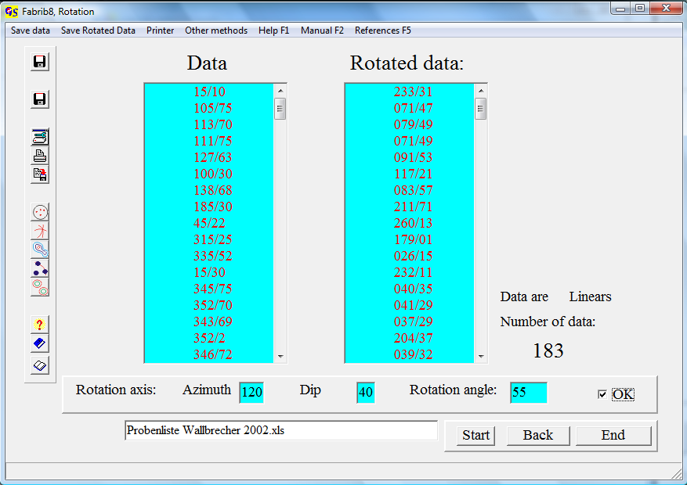
Fig. 18
In thr menu “Other Methods” you can plot the rotated data, draw great circles, if data are planes, make a contour line plot, make a statistical evaluation, or make a test of significant submaxima.

